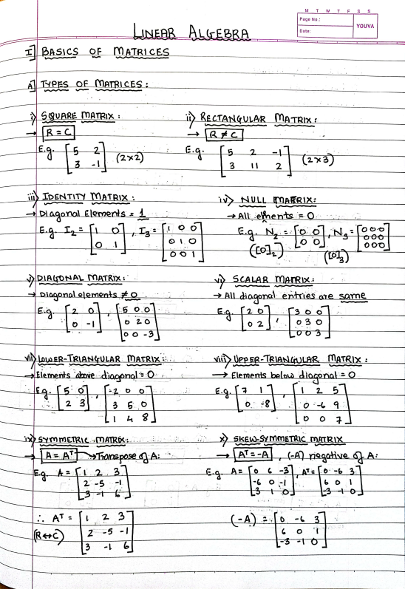CamScanner

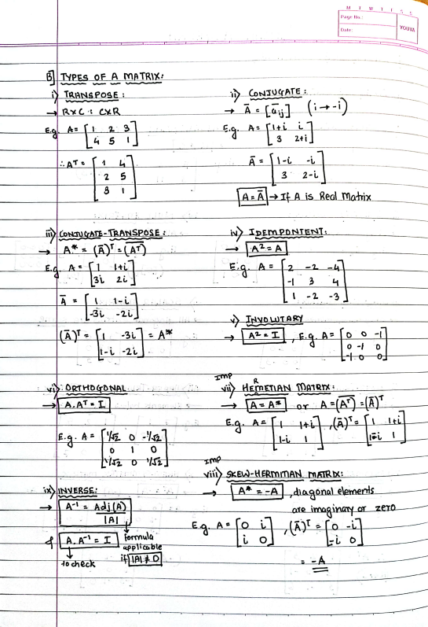CamScanner

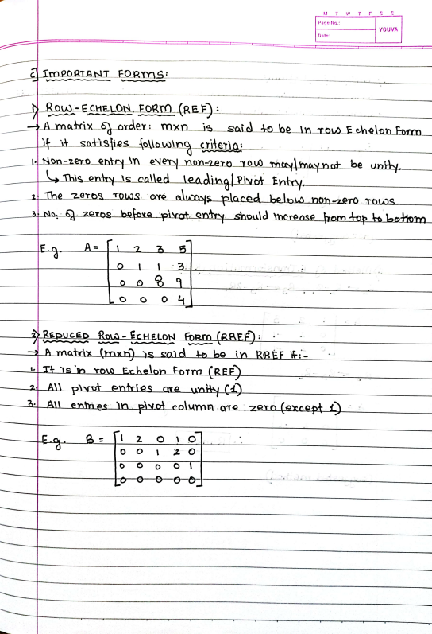CamScanner

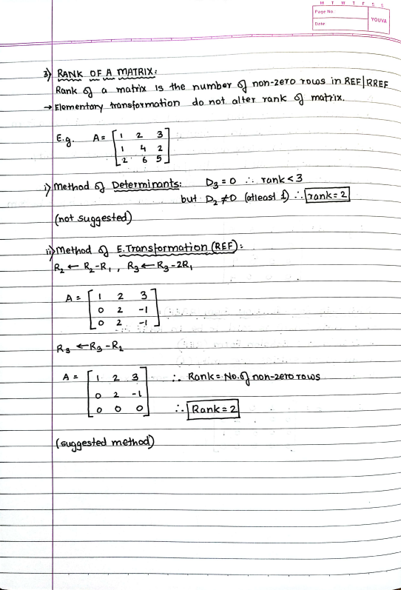CamScanner

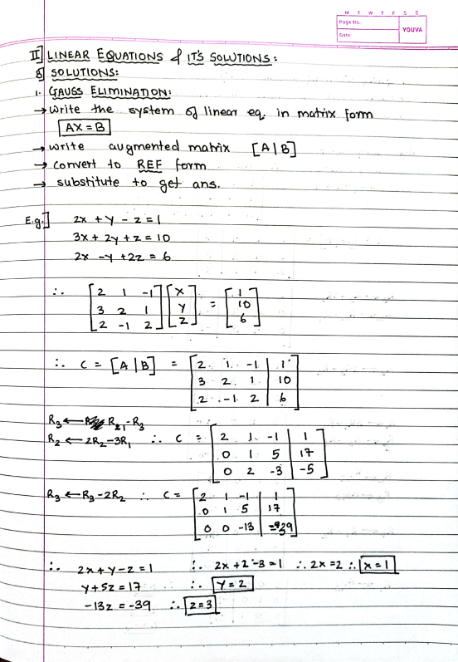CamScanner

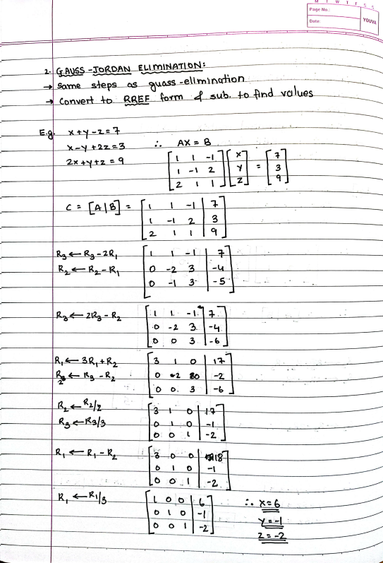CamScanner

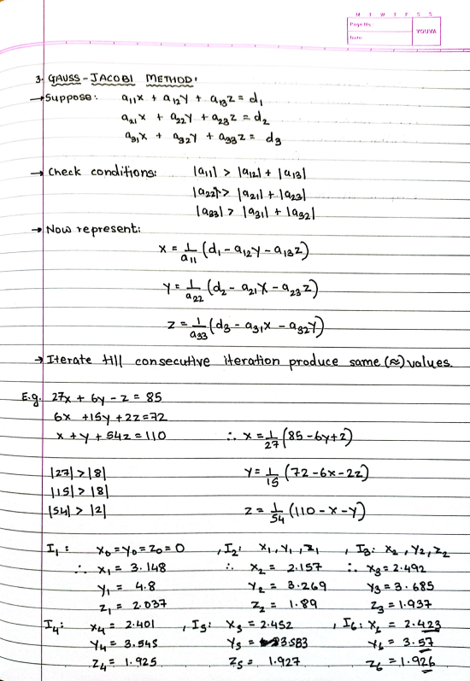CamScanner

CamScanner

CamScanner

CamScanner

CamScanner

CamScanner

CamScanner

CamScanner

CamScanner

CamScanner

CamScanner

CamScanner

CamScanner

CamScanner

CamScanner